**User Manual**

**Introduction:**

This site were made for you to avoid cheating and no warrenty products. All our products have warrenty also most of them have discount.

**How site works:**

Unlike other sites, this site is pretty simple. All what you have to do is to follow our steps to buy products.

* Step 1

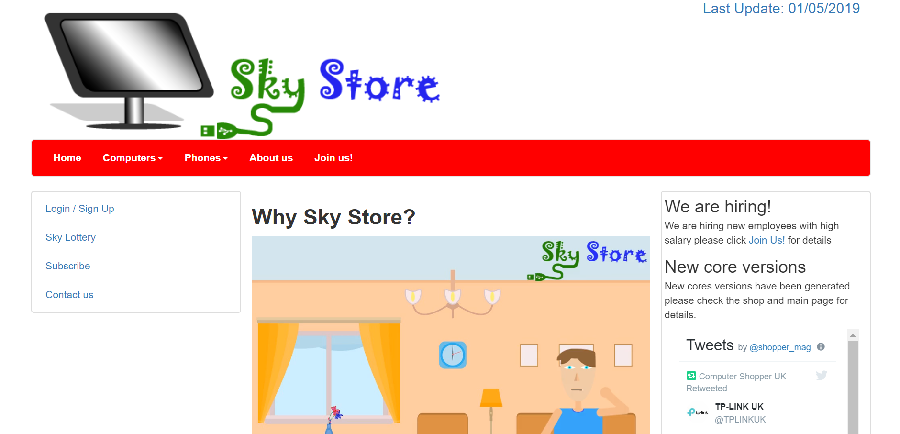

That’s our site and our logo, also there is a video telling why using our website instead of using other commertial websites.

You can see the following in website header navigation:

* + Home:
    - Which sends you to the homepage if you want to back to the homepage
  + Computers
    - Here you can choose what computers type you can browse and buy.
  + Phones
    - Also in this section you can choose phone type e.g. android, iPhone, etc…
  + About us
    - Here you can see details about us and also this manual
  + Join Us
    - In this section if you see or like joining us don’t wait read details there and send us your data and CV and we will review it and send you E-mail if you are accepted.

You can see the following in website side navigation:

* + Login/Sign up
    - To login or to create account
  + Sky lottery
    - Here you can try your luck there are cool rewards if you win such as PCs or Laptops and so on
      * Note:
        + You much first purchase any of our items
  + Subscribe
    - This section allows you to type your E-mail to receive any new items and new about our website.
  + Contact Us
    - And here you can see how you can communicate with us in case something happened or asking for something or any other reason we always glad to receive calls from our customers.
* Step 2

You can see the following in website side navigation:

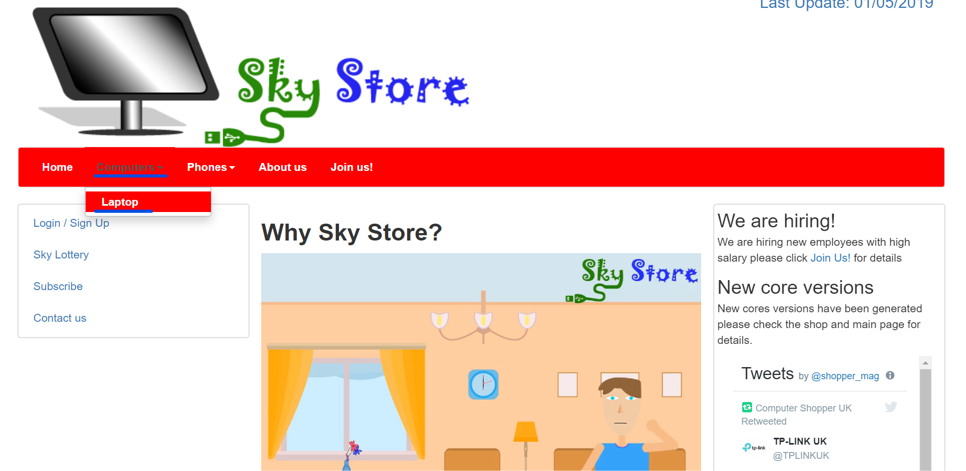

As you see you can just click on computers or phone and choose the category you want

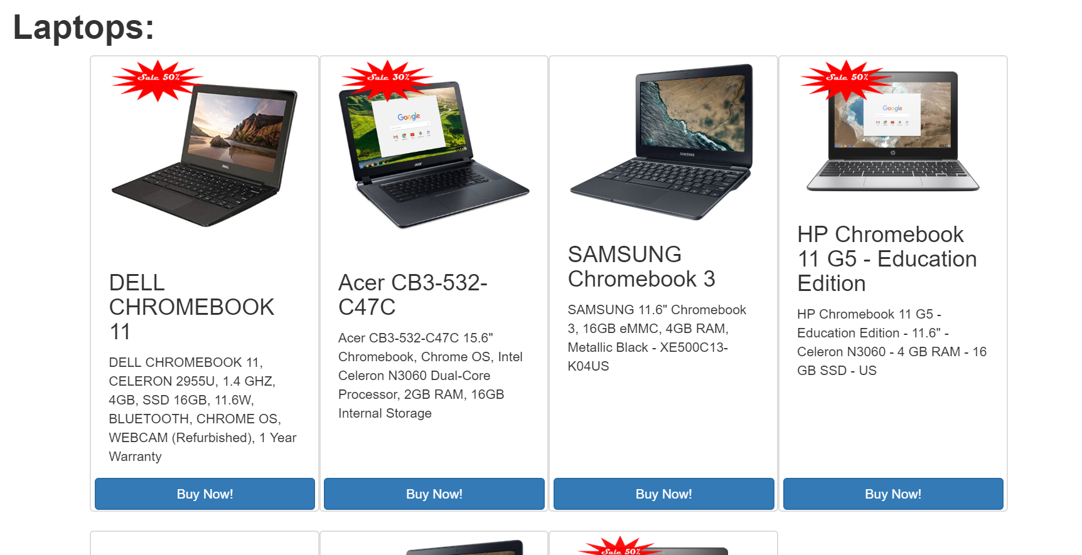

After clicking on the category you want you can scroll down and browse laptops and its details

If you want to buy and of them just click buy now and it will be send to cart

* Step 3

About signing up

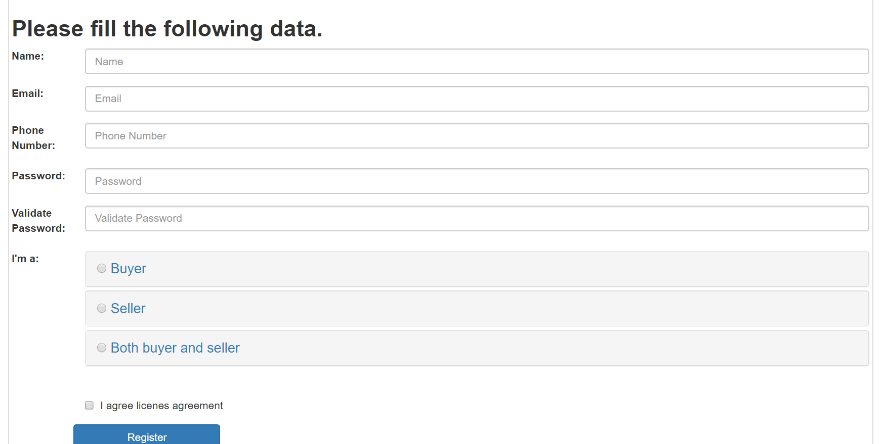

You can choose:

* + Buyer:
    - If you only buy devices for your own or for selling it in another place.
  + Seller:
    - If you only sell in market for your own or for company.
  + Both buter and seller:
    - If you are a user or a company and you buy and sell devices.

**Note:**

If you faced any problem, please contact us on the following email:

support@skystore.mytopleveldomain